Name : Sakthi Manoj R Reg No : 192324236
PROGRAM 17
Explore the Titanic Dataset Using Bar Charts and a Histogram
Aim:
To explore survival patterns in the Titanic dataset using bar charts for class and gender and a histogram of age when age data is available.
Procedure:
Step 1: Open RStudio or the R console on your computer.
Step 2: Load the built-in Titanic dataset using data("Titanic").
Step 3: Convert the Titanic table into a data frame using as.data.frame().
Step 4: Create a bar plot to show the relationship between passenger Class and Survived using table().
Step 5: Create another bar plot to compare survival by Sex.
Step 6: Add suitable titles to both bar plots.
Step 7: Observe the plots to compare survival patterns across passenger classes and genders.
Step 8: Note: The built-in Titanic dataset contains grouped counts and does not include individual Age values; use a separate Titanic passenger dataset to create an age histogram.
Output :
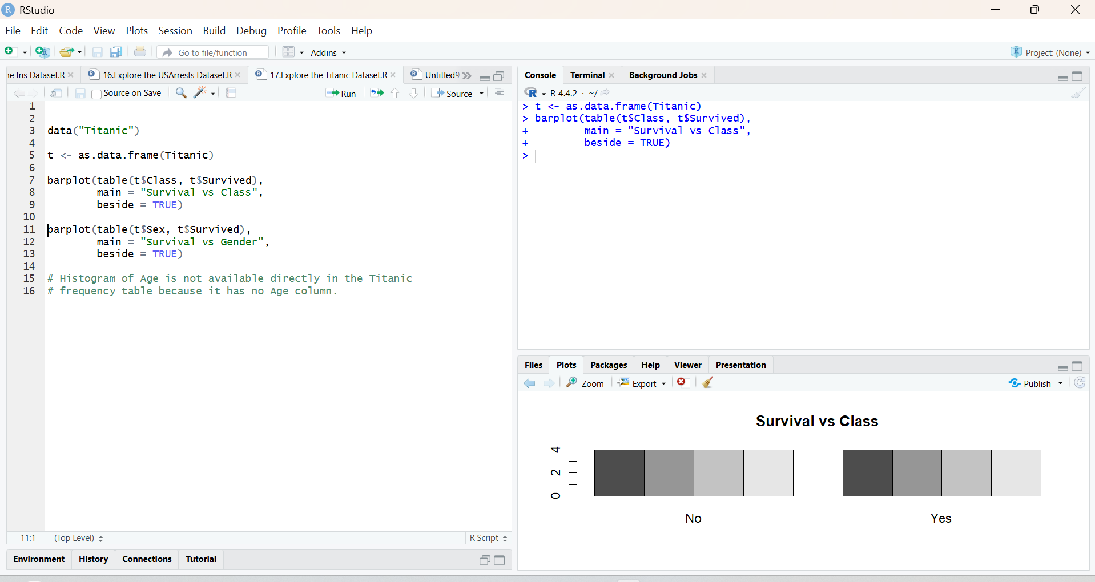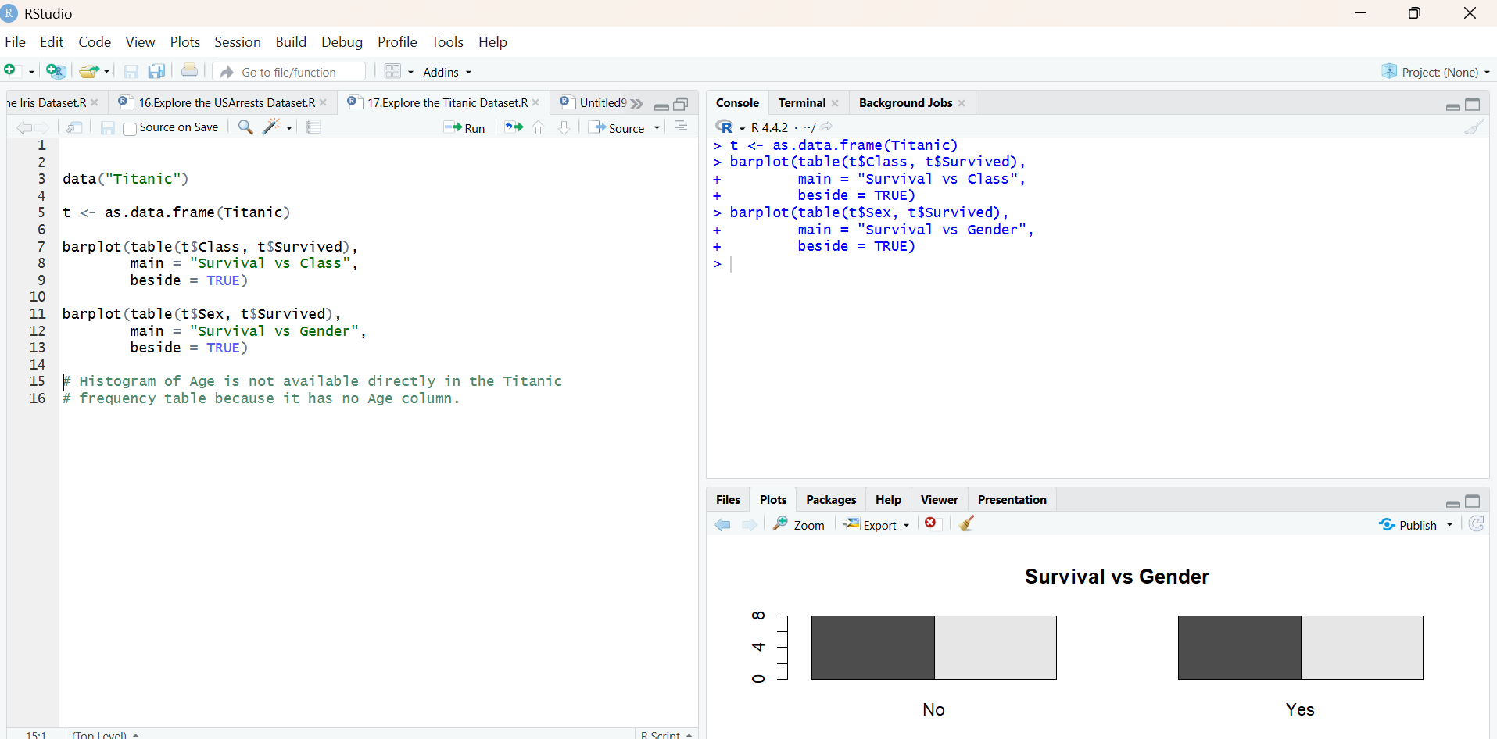
Result:
Hence the output is verified successfully.

